[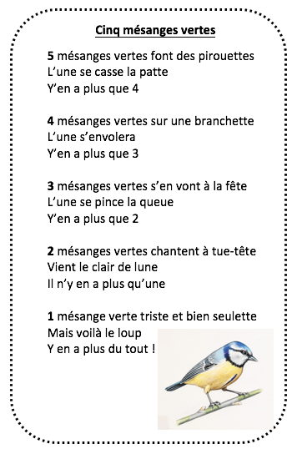](https://p6.storage.canalblog.com/62/29/1127151/119155126_o.png)